Lab: Collaborate on a Shared Codebase with GitHub
Working with a team on the same codebase? In this hands-on lab, you’ll use GitHub (a remote repository host) to collaborate smoothly and keep everyone in sync.

Learning Objectives
- Create a repository on GitHub
- Link your local repo to the remote (set origin)
- Push local commits to GitHub
- Fetch and pull updates from the remote to stay up to date
By the end: you’ll know how to connect your local work to GitHub and sync changes both ways—without stepping on anyone’s toes.

Prerequisites
- A text editor (Vim, Visual Studio Code, or any editor you prefer)
- Git installed
- A GitHub account (it’s free)

Steps to follow:
This is a continuation of the previous labs [Lab - Working with Git Branches ]

Open the visual studio code, navigate to the code and switch to the master (or main) branch.

We already have committed changes to the master (or main) branch but in the local git repository.

Let us now create a remote repository and push this code to Github Repository.

Step 1 - Create a remote repository

- Navigate to your Github account.

- Login with your credentials

- Click New on the right side of screen (see the screenshot below)

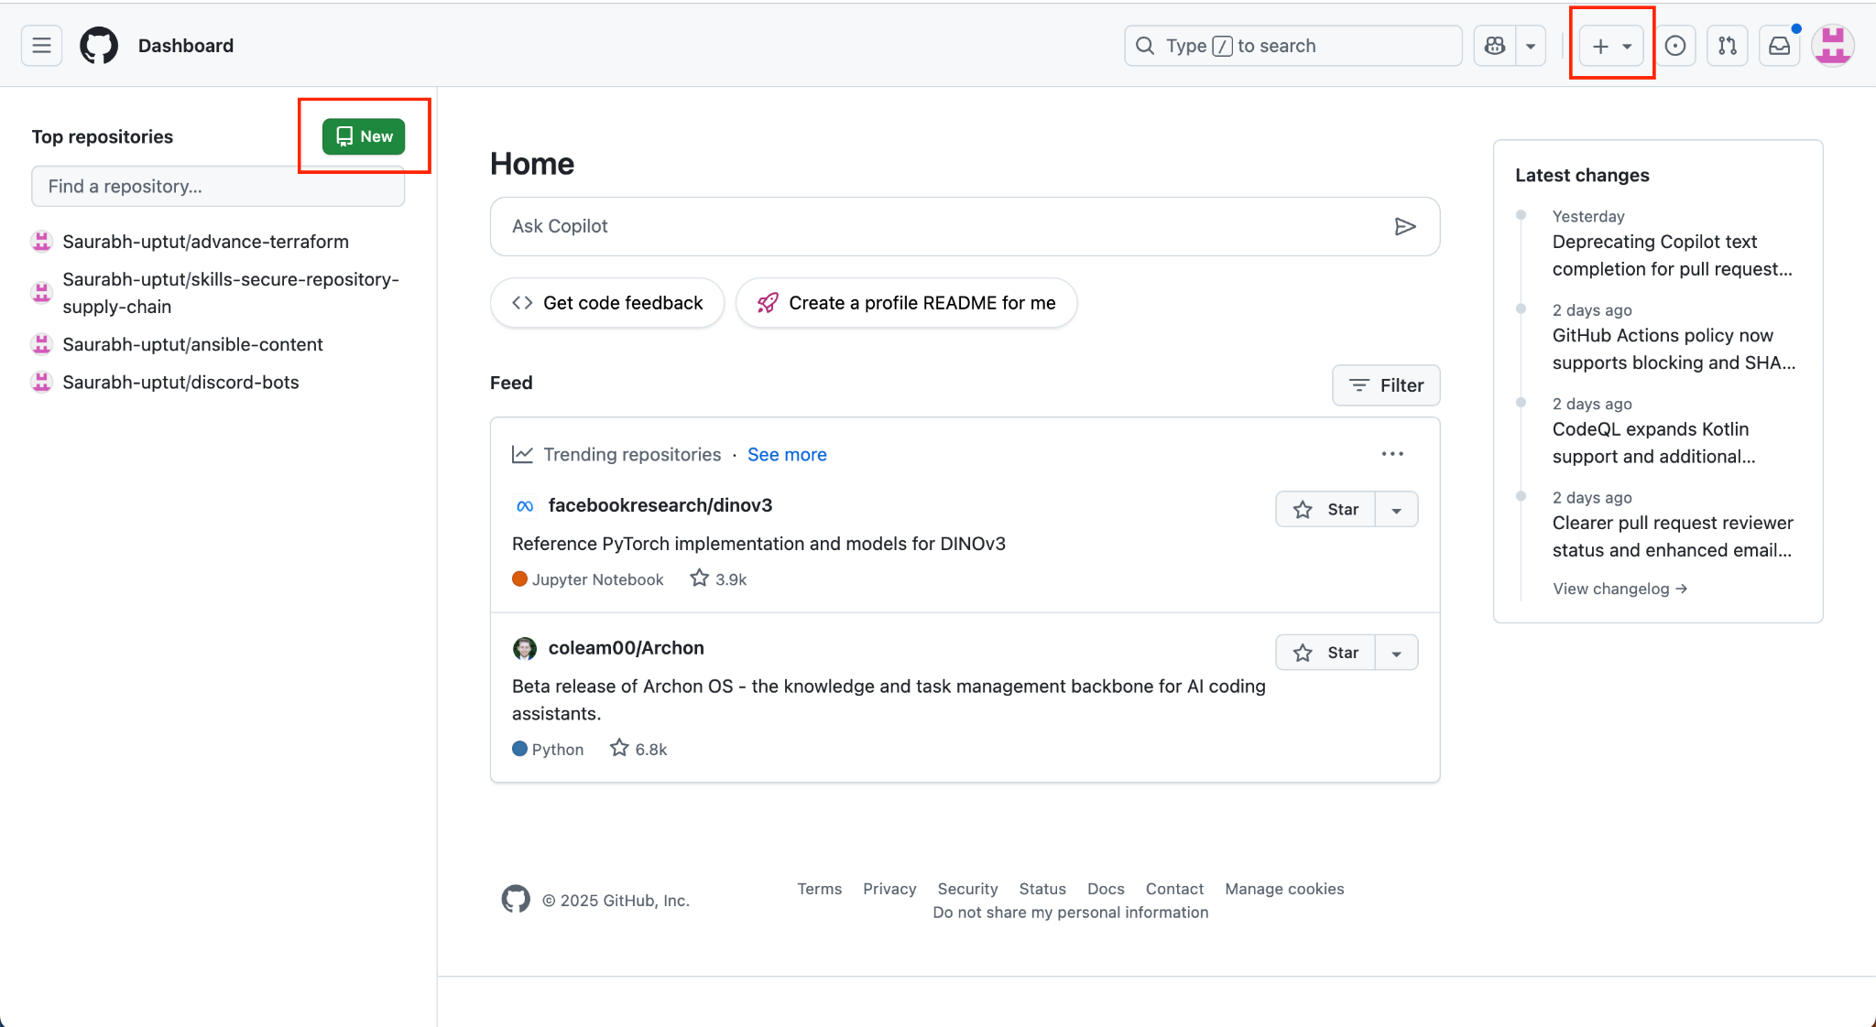

- Enter the repository name of your choice, ex - practice-git-workflow. Keep all other settings as is and click Create Repository.

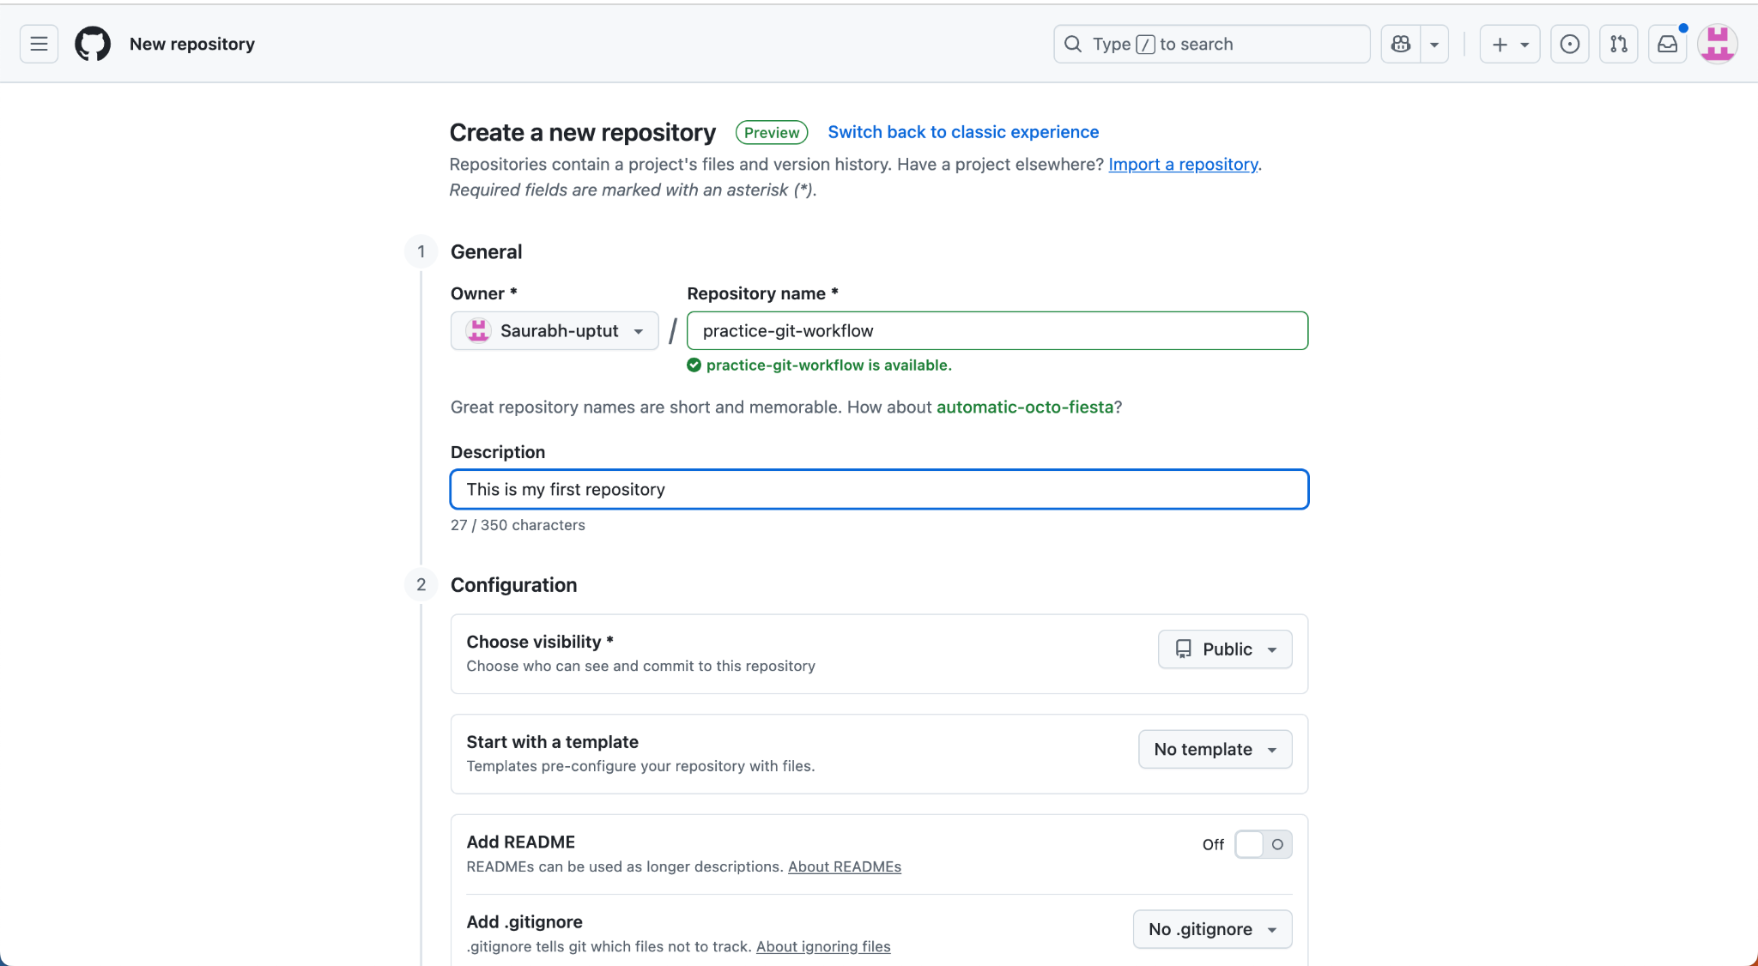

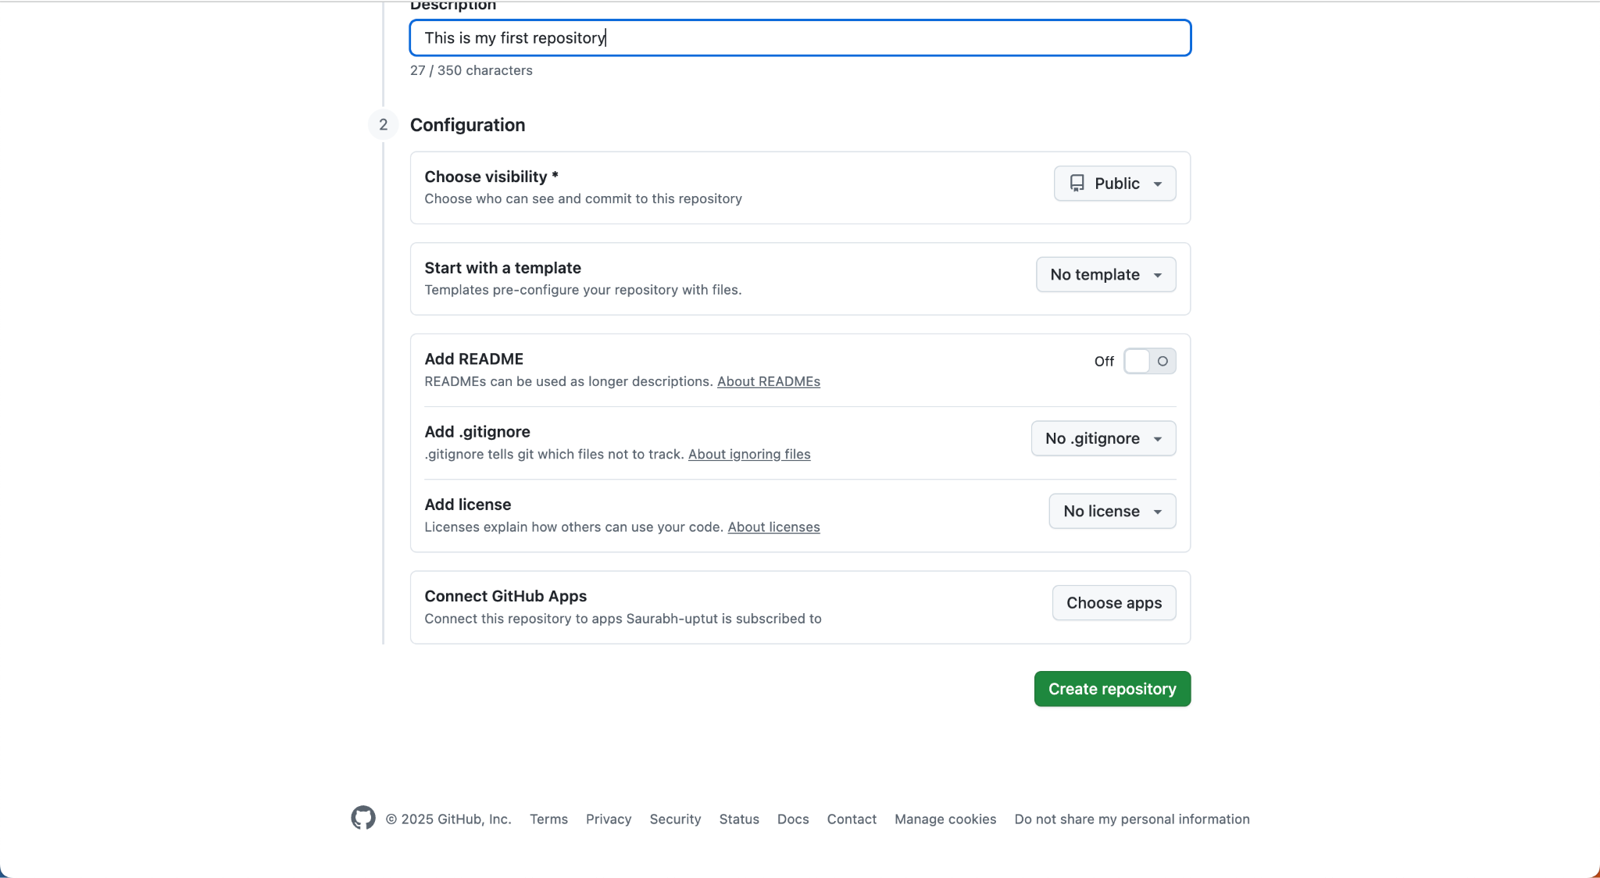

Copy the URL of your repository as shown in the screenshot below

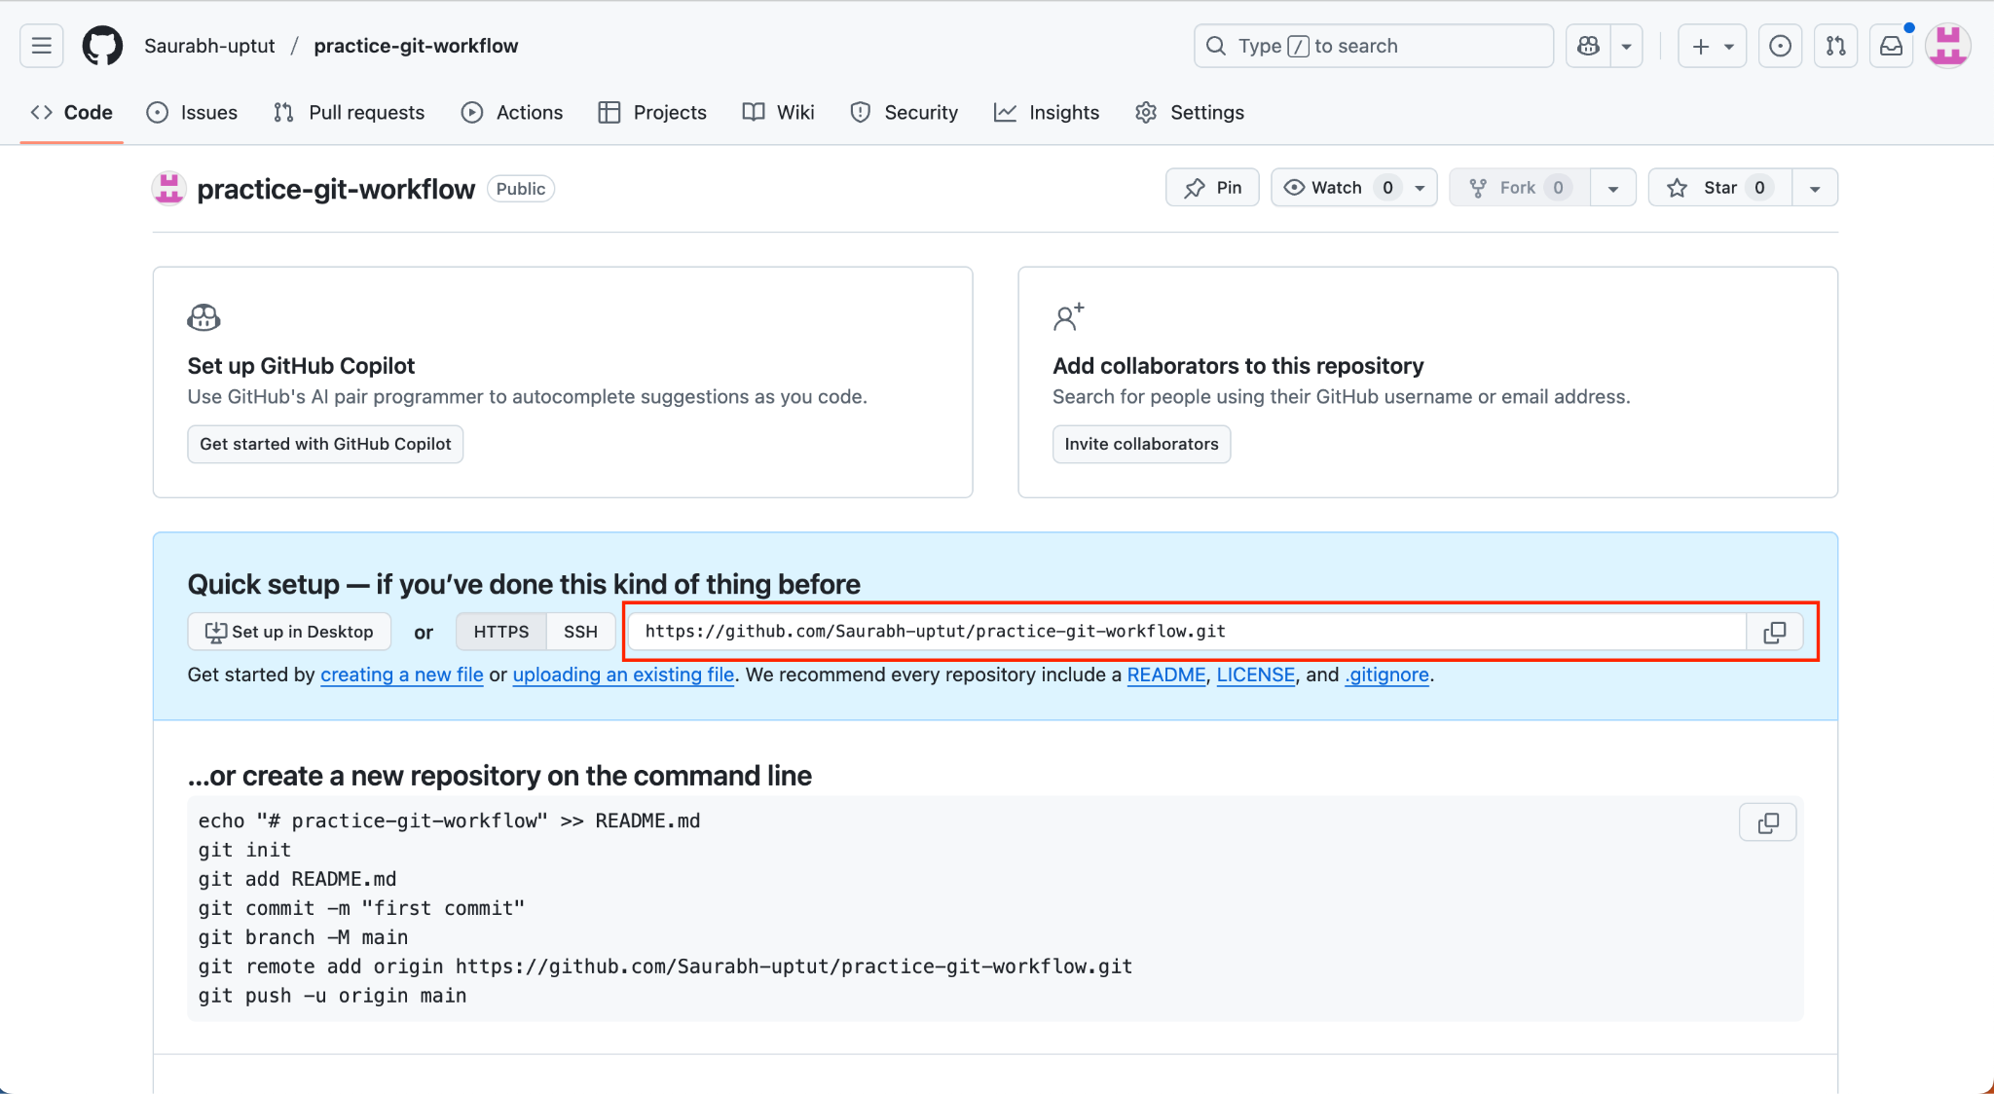

Step 2: Generate the personal token

Navigate to the User Icon on the top right corner of your Github account.

Select Settings

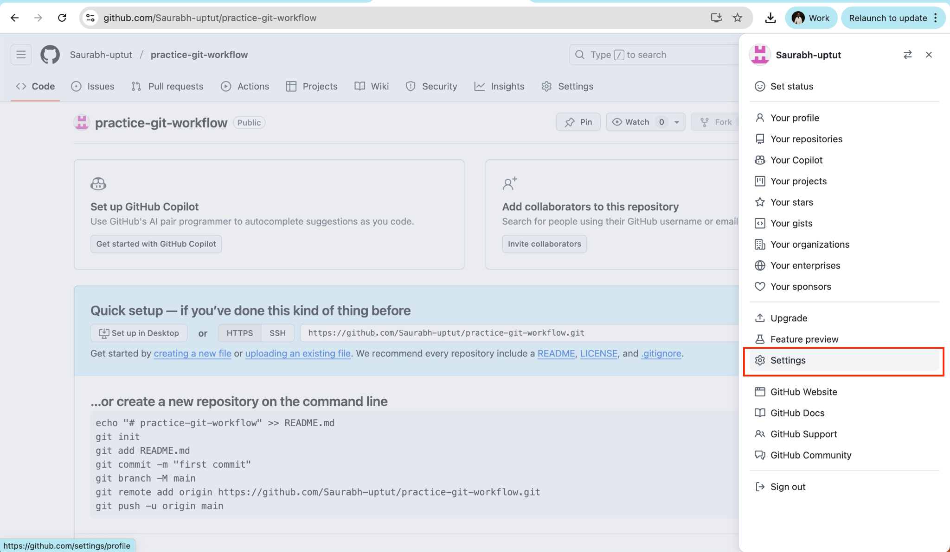

Select Developer Settings from the right bottom link

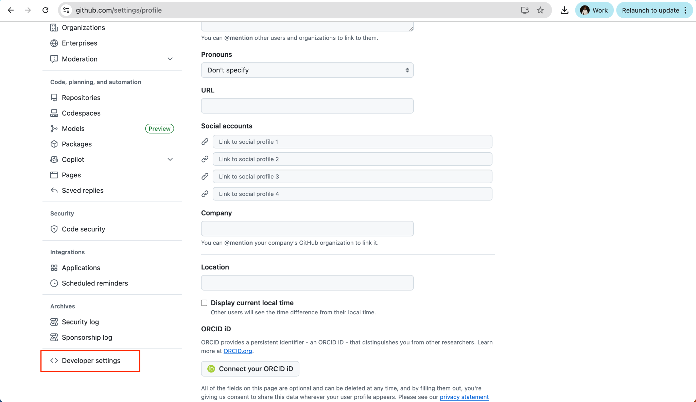

Select Personal Access Tokens >> Fine-grained Tokens
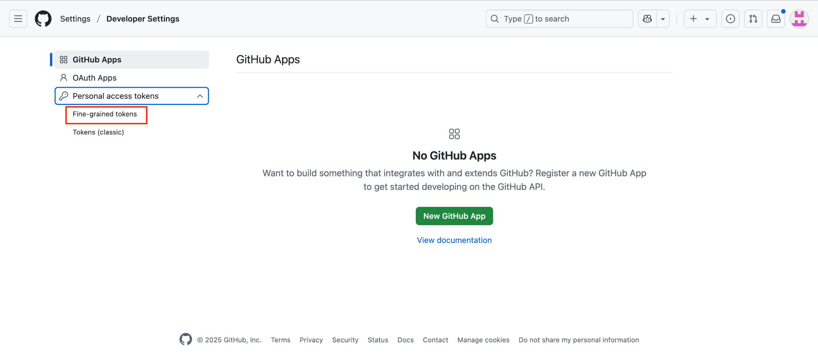

Select the Generate new token

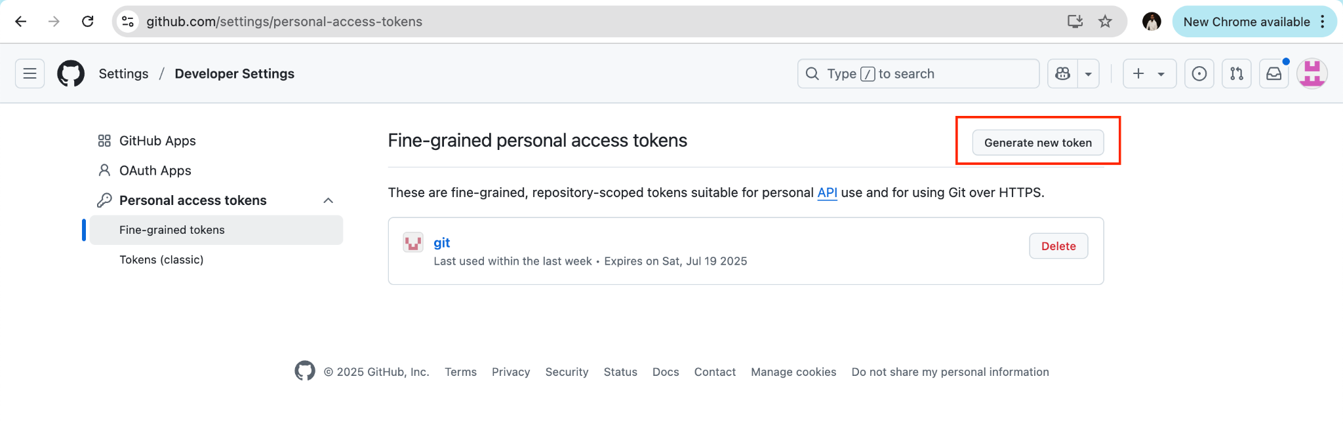

Enter “Token Name” and “Resource Owner”

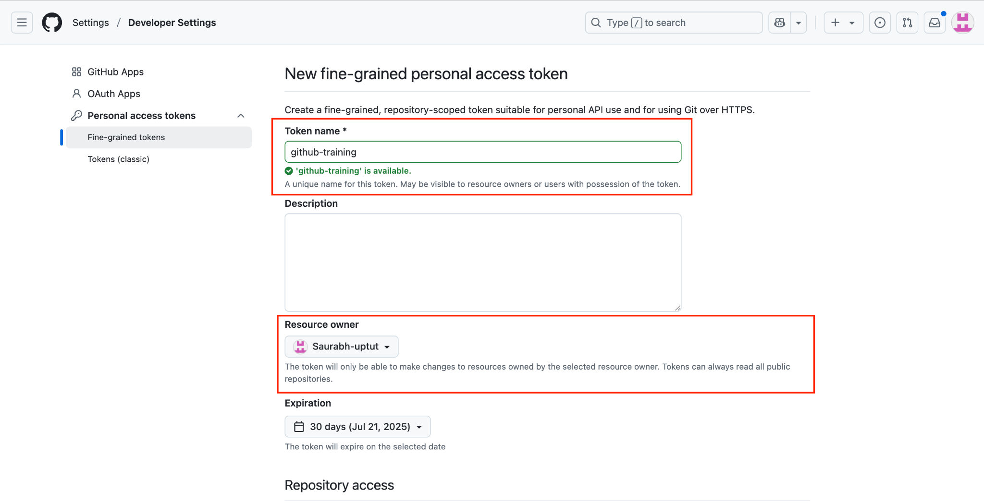

Select “All repositories”

Note - This section you can use to restrict access to the repositories

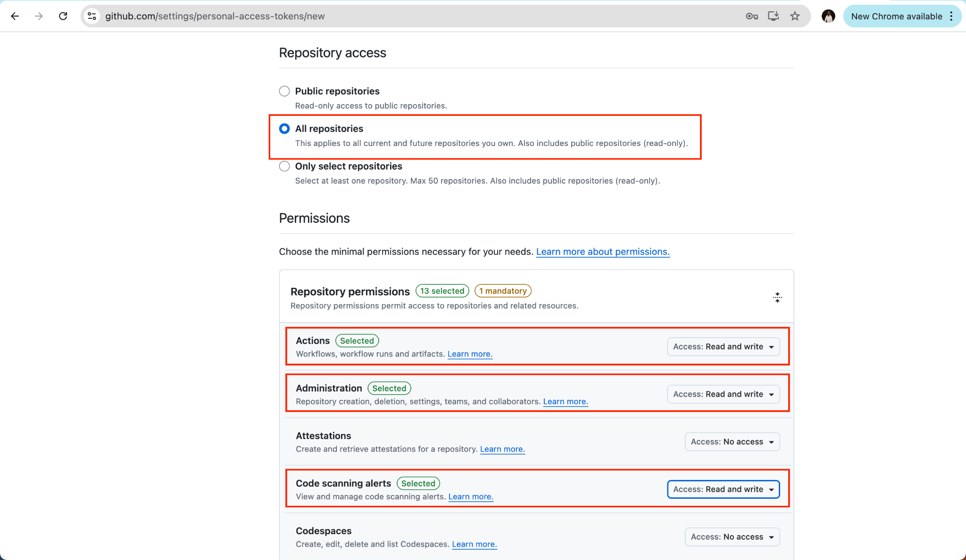

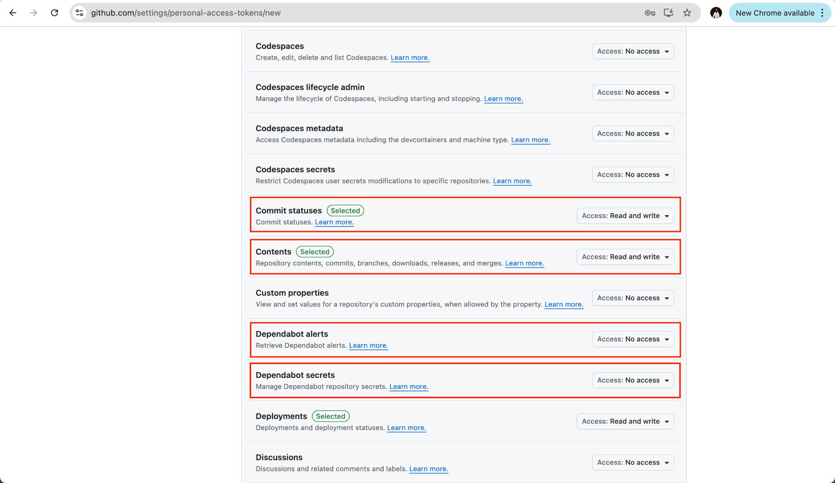

Click Generate Token.
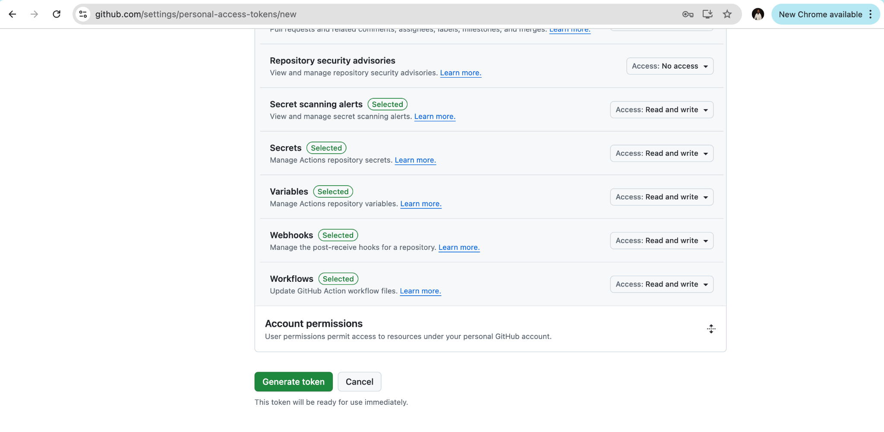

Note - Keep a note of the personal token generated at this stage. This token will be used to communicate with the Git.

Step 3: Push the changes

Update the remote repository URL in your workspace.

Switch to the Visual Studio code and execute the following command.

git remote add origin https://github.com/Saurabh-uptut/practice-git-workflow.git

Notice the URL of the remote repository. We have added the username before the repository name.

Next, push the code to the remote repository.

git push --set-upstream origin master

This step will ask you to pass the personal token. Enter the token to press enter. It will push the changes to the remote repository.

origin here is the name of the remote repository

Step 4: Pull Changes

- Let us first make some changes to the remote repository. Navigate to the code repository. Make changes to any of the files, say README.md file via the Github UI.
- Switch to the Visual Studio code and make sure you are in the correct folder.

# Check status
git status

# Fetch changes from remote
git fetch origin

# See what's different
git log --oneline --graph --all

# Pull changes
git pull origin master

Verify that the changes are visible in the README.md file.

